Wednesday 13th May 2020
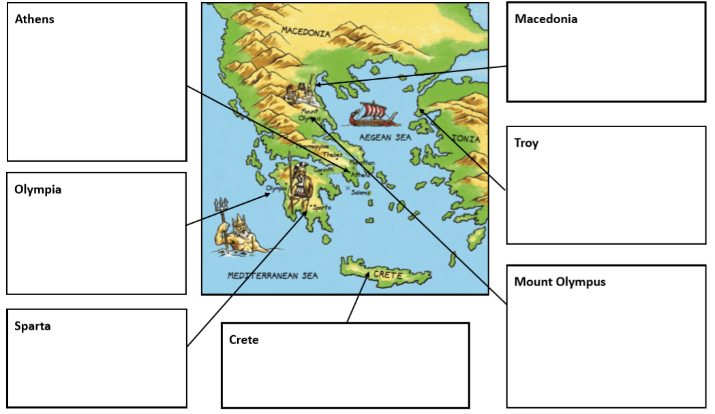
Ancient Greece

