The functions of a skeleton
A skeleton has 3 main jobs, these are:
- To protect the body
- To support the body
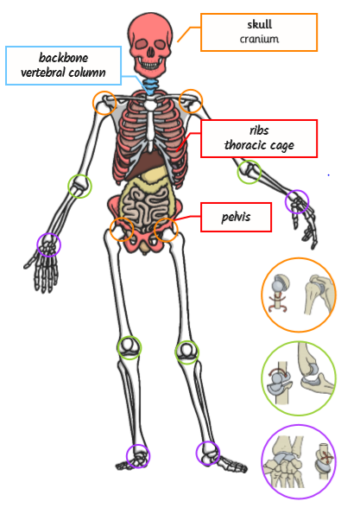
- To allow our bodies to move in different ways
Job 1 – Protection
The bones labelled and coloured in red are the bones that protect the organs in your body (ribs skull, pelvis).

Job 2 - Support
The bone coloured and labelled in blue is called your backbone (spine). The backbone is the part of the skeleton that supports your body.

Job 3 – Movement
Your body can move because of all the joints it has.
Your body has 3 different kinds of joints:
- The ball and socket joints – these are circled in orange on the skeleton.
- The hinge joints – these are circled in green on the skeleton.
- The gliding joints – these are circled in purple on the skeleton.

