Map of Europe

Can you label the countries in Europe?
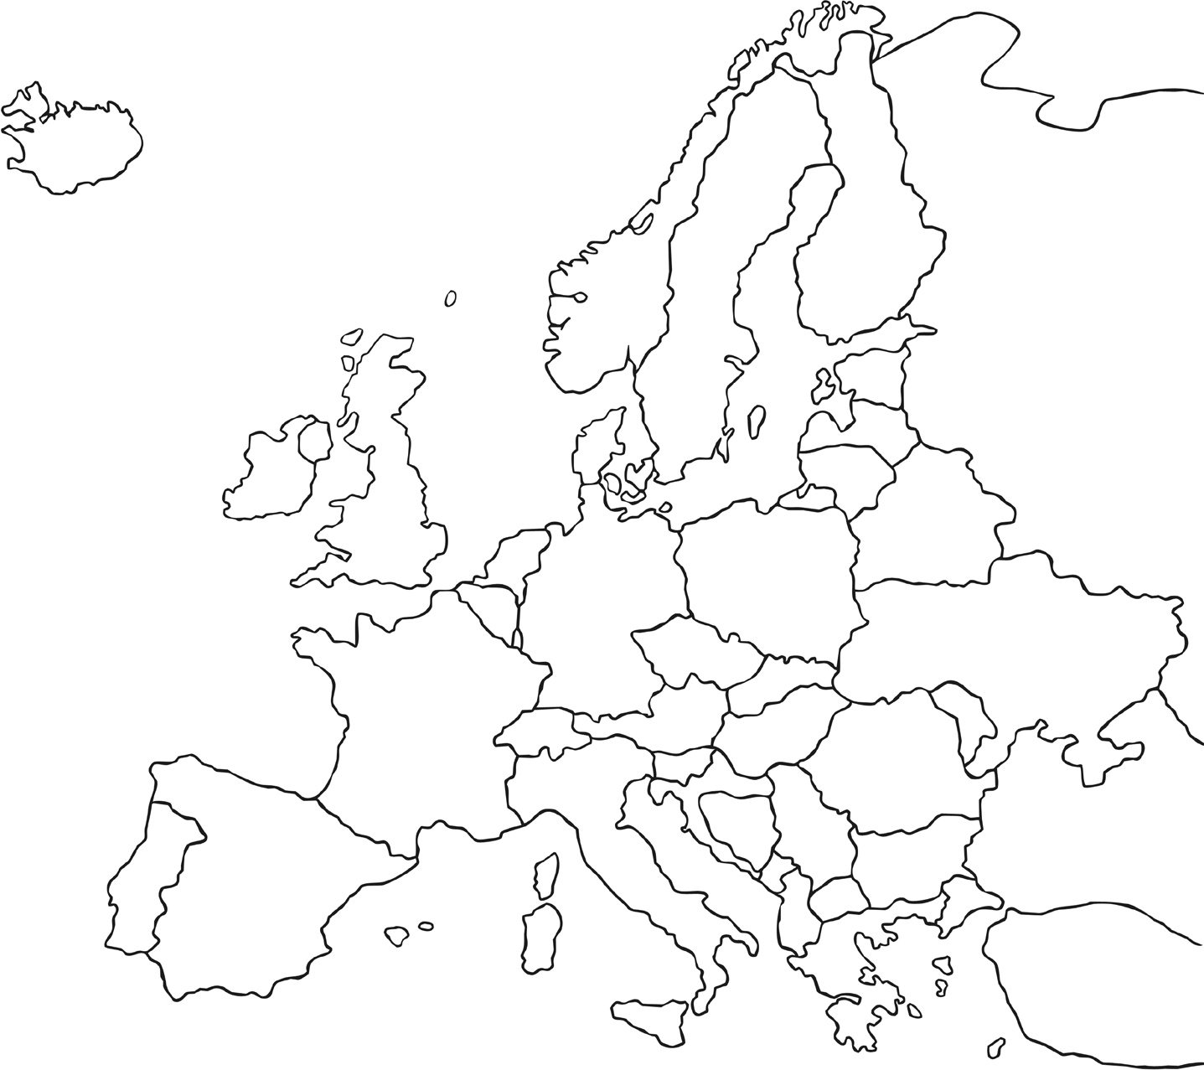

Extension: Can you locate and colour the following countries?
- Greece – red
- Spain – blue
- United Kingdom – yellow
- Finland – green
- Germany – orange

