Multiplication Triangles.
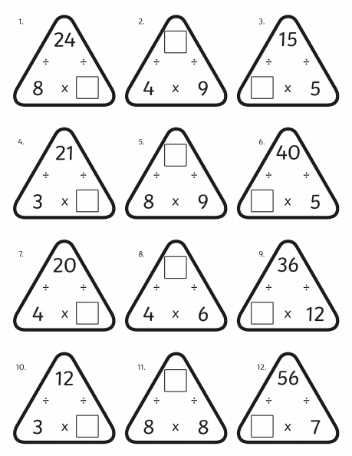
Fill in the blanks in these multiplication triangles.
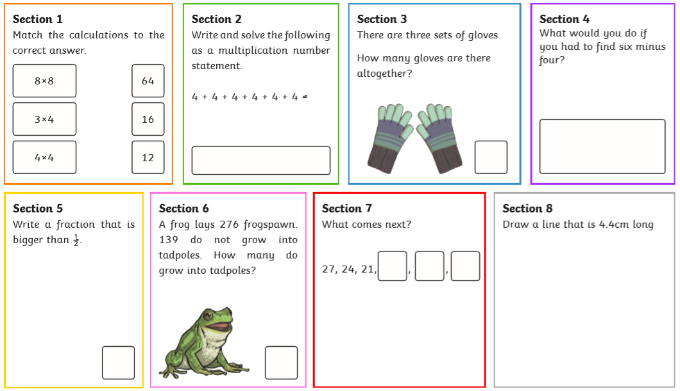
Now complete the questions on this Maths activity mat:

