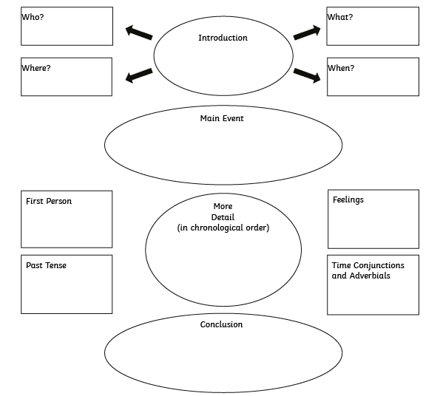
Planning your diary entry:
Some suggested activities that you might get up to as a Celt:
- Sweeping the floor
- Feeding the chickens and gathering their eggs
- Decorating a new cooking pot using Celtic designs
- Weaving cloth and dyeing yarn
- Collecting water from the local stream for drinking and washing
- Polishing your helmet and armour
- Cooking dinner over the fire
- Working in a field and hunting for food
A suggested writing frame:
Date: _________________
Dear Diary,

This morning I ___________________________________________
____________________________________________________
I felt ________________________________________________
____________________________________________________Then I ________________________________________________
________________________________________________________________________________________________________
After that I ____________________________________________
____________________________________________________
At the End on the day I ______________________________________
____________________________________________________
____________________________________________________
Tomorrow I hope to ________________________________________
____________________________________________________

Love from,
________________________
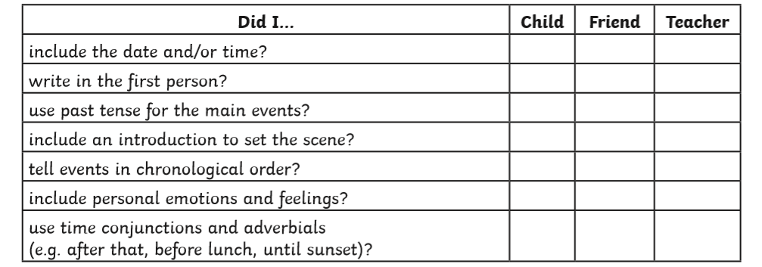
Checklist:

