HA
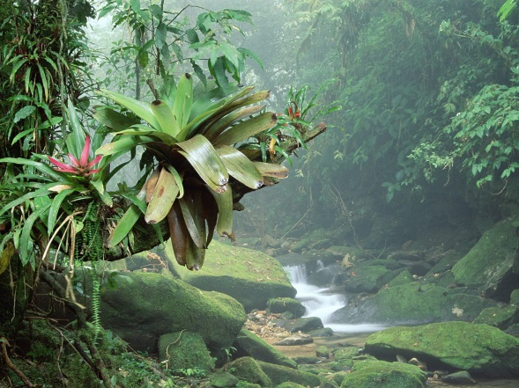
Task: Describe a rainforest setting- use adjectives, similes etc to up-level your writing and make it as detailed and interesting as possible.
________________________________________________________________________
________________________________________________________________________
________________________________________________________________________
________________________________________________________________________
________________________________________________________________________
________________________________________________________________________
________________________________________________________________________
________________________________________________________________________
________________________________________________________________________
________________________________________________________________________
________________________________________________________________________
________________________________________________________________________
________________________________________________________________________
________________________________________________________________________
________________________________________________________________________
________________________________________________________________________
________________________________________________________________________
________________________________________________________________________
________________________________________________________________________
________________________________________________________________________

