Roman Forts
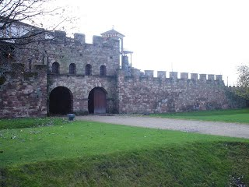

Roman forts were large camps where soldiers could live comfortably while fighting.

They were often built in a square shape and were protected by: strong walls, towers and
ditches. Each side had a fortified gateway.

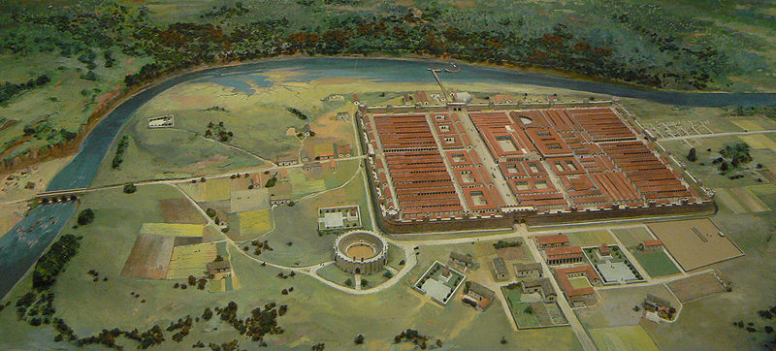

The soldiers kept watchdogs to smell any approaching enemies and sent out spies to report
on suspicious enemy activities. In an ambush, huge catapults called ballistas
would fire out iron bolts.

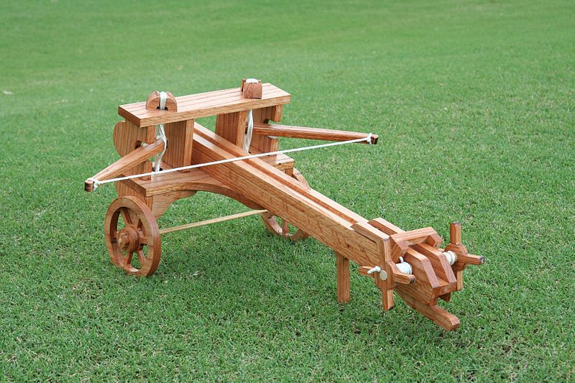

Inside there were buildings to cater for all the soldiers' needs from: eating, sleeping and
washing to banking and praying. There was also a small hospital to look after the sick
and injured.

A little village called a vicus grew up around many forts in which the local people
would run take-away food stalls and inns for the soldiers to relax in off-duty, in return for
money and protection from attack.

