VE Day Maths Board Game
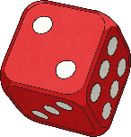
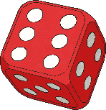
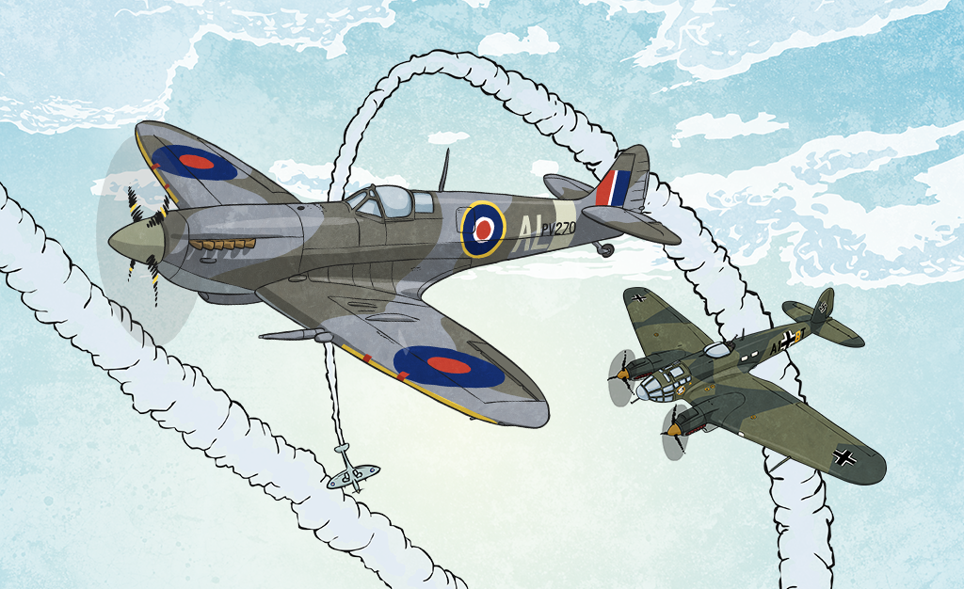
1. Take it in turns to roll the dice.
2. Move that number along the trail and find the answer to the question you land on.
a. If you get the answer wrong, you miss your next turn.
b. If you get the answer correct, you can have your next turn as normal.
3. The first person to reach the finish line wins.
How to Play

During the Second World War, board games were a popular form of entertainment. Games like draughts, chess and dominoes all helped to keep people’s spirits up.

Start

+ − × ÷
+ − × ÷

+ − × ÷

+ − × ÷

Go back
to start

+ − × ÷

+ − × ÷

+ − × ÷

+ − × ÷

+ − × ÷

Go forward
3 spaces
Miss a go

Go back
2 spaces

+ − × ÷

+ − × ÷

+ − × ÷

+ − × ÷

+ − × ÷

+ − × ÷

Go forward
one space
+ − × ÷

+ − × ÷

+ − × ÷

+ − × ÷

+ − × ÷

Move back
63 ÷ 9
Move back
96 ÷ 12
Go forward
one space
+ − × ÷

+ − × ÷

Move
forward
4 spaces
+ − × ÷

+ − × ÷

+ − × ÷

Finish

