Walford Primary School  Walford  Ross on Wye  Herefordshire  HR9 5SA  www.walfordprimaryschool.co.uk |  | Ms Louise George  Headteacher  BA (Hons) MA NPQH  Tel: 01989 562209  Fax: 01989 762898  admin@walford.hereford.sch.uk

Tuesday, 9th October 2018

Dear Parents/Guardians

School Disco

We will be holding a school disco on Wednesday, 24th October 2018.

Disco tickets are available to purchase from the school office or alternatively you can complete and return the form below with your payment. Tickets are £2.50 Entry Fee / £3.50 Entry Fee including a hot dog. There will also be an opportunity for children to purchase sweets and so we recommend that the children bring £1/ £2. Free squash will be available on the night. Please note the following details:

5.00pm - 6.00pm Infant Disco YR, Y1 & Y2

6.15pm - 7.30pm Junior Disco Y3, Y4, Y5 & Y6

Yours sincerely

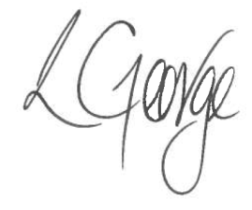

Ms. L George
Headteacher

……………………………………………………………………………………………………………….

Child’s name……………………………………………………………..Class………………………….

I would like to purchase a £2.50 ticket to the disco.

I would like to purchase a £3.50 ticket (including a hotdog) to the disco.





Signed……………………………………………………………Date…………………………………….

