Walford Primary School  Walford  Ross on Wye  Herefordshire  HR9 5SA  www.walfordprimaryschool.co.uk |  | Ms Louise George  Headteacher  BA (Hons) MA NPQH  Tel: 01989 562209  Fax: 01989 762898  admin@walford.hereford.sch.uk

Wednesday, 06 June 2018

Dear Parents/Guardians

Sports Day

Tuesday, 26th June 2018

Key Stage 1 (YR, Y1 and Y2) will have the opportunity to compete in a selection of fun races (sprint, egg 'n' spoon, obstacle) during the morning between 10.00am and 11.30am. After lunch, Key Stage 2 (Y3-Y6) will participate in a range of competitive races between 1.15pm and 2.45pm.

Parents are invited to celebrate with us throughout the day and join us for a picnic lunch on the school field between 11.45am - 1.00pm (hot lunches will not be affected). During lunch, the PTFA will sell ice creams/ice lollies for children and families to purchase at a cost of £1.

Should the weather not be kind to us, a decision will be made as to whether the planned event should be cancelled and a message will be put on the School Website as early as possible for your information. With so many exciting events organised for the children this term, it will not be possible to organise an alternative date.

We hope to see you there!

Yours sincerely

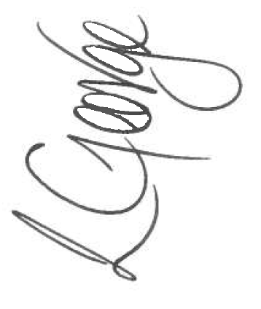
Ms L. George
Headteacher







