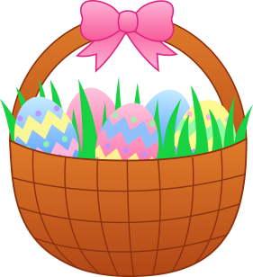
The Great Easter
Bake Off!
Cupcakes, Cakes and Biscuits Welcome
Tuesday, 27th March 2018
Children that would like to participate are invited to bake cakes/cupcakes or biscuits and decorate them with an Easter theme. Prizes will be given for the winning baker in each class.
Bakers must bring their goods to the hall before 09.00am where tables will be assigned for each class. Judging will take place at 9.30am and then the cakes will go on sale at break time and after school.
On your marks, get set, BAKE!
Easter Chocolate Hamper
Attached to this letter is £2 worth of raffle tickets. We would be very grateful if you could sell the tickets on our behalf. Please write the name and telephone number of the person who buys the ticket on the reverse of each ticket.
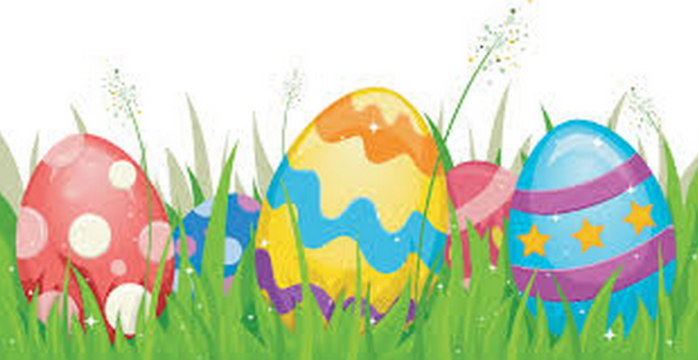
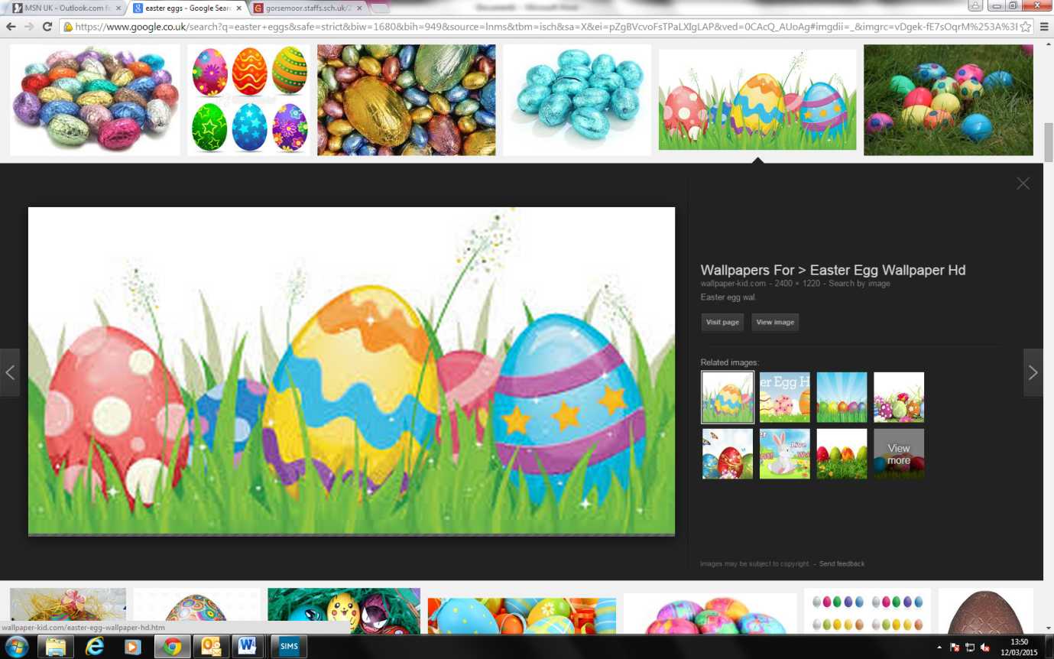
Please return one half of the strip together with the correct money by Monday, 26th March 2018. If you need any more tickets please speak to the school office.

