KS2 Pupil Voice Computing

Responses collected using SurveyMonkey in February 2020.
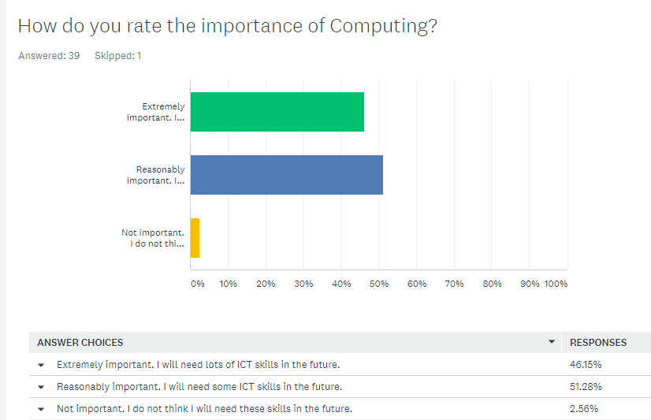

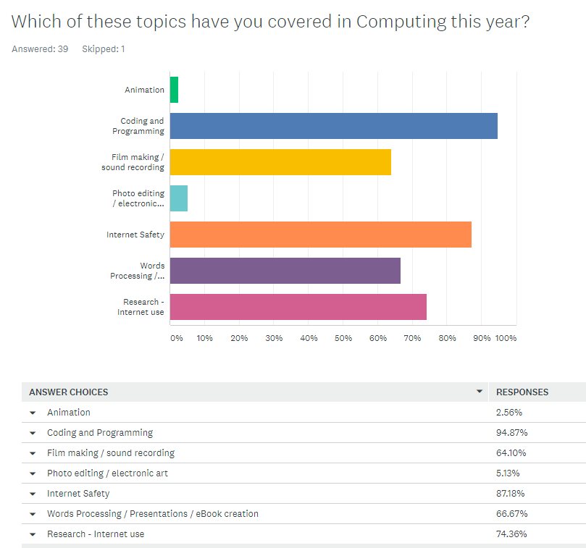

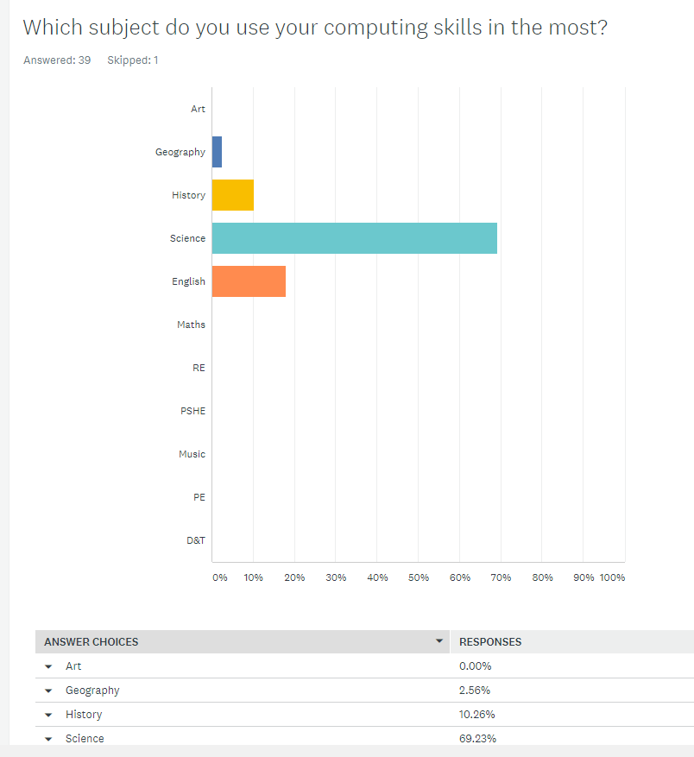

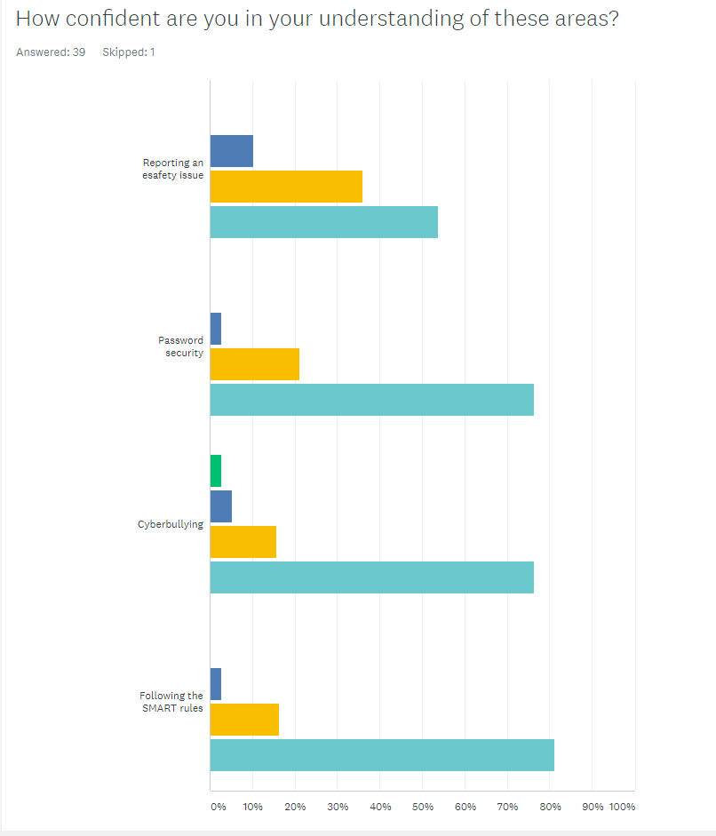

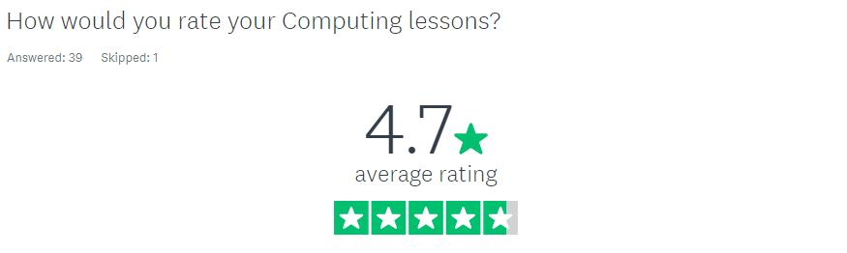

What do you enjoy most about computing at Walford Primary School?
Responses included:
- Making keynote presentations.
- Coding and programming things.
- I like doing coding.
- It is challenging and fun!
- I like making codes and having fun on the iPads, also I like making books for our buddies on book creator. It is fun and cheerful.
- I like the lessons that are linked with computing.
- You can learn a lot and it helps you stay safe online.
- How fun the teachers make it (computing lessons) and we learn a lot.
- Making movies and the Walford Oscars!

Is there anything you would improve about computing at Walford Primary School?
Responses included:
- I don't think it could improve because it fun and you can learn a lot.
- Yes, when we go on the iPads we could choose our partners.
- I wouldn't improve anything!
- I wish I could do my typing a bit quicker.
- No, there is nothing that we can improve at Walford Primary.
- More coding and animation.
Many children answered ‘no’ or ‘nothing’ to this question.



