Parents’ Support Guide to Spelling, Punctuation and Grammar in Year 1.

Writing
By the end of Year 1 most children should know.,,
- How words can combine to make sentences.
- How to join words and clauses using and .
- How to sequence sentences to form short narratives.
- How to separate words with spaces.
- How to use capital letters, full stops, question marks and exclamation marks to demarcate sentences.
- How to use capital letters for names of people, places, the days of the week and for the personal pronoun I.
- What nouns, verbs and adjectives are.
- How to include story language and patterns e.g. one day, suddenly, in the end.

Useful Activities
Reconstruct
Write a sentence together. Print your writing out in big lettering including the full stop. Cut into individual words, including the full stop. Help the children to reproduce the sentence, by holding the cards in front of them. As you do more of these, collect them together and save for future use.

Expand
You can build up and develop sentences by asking questions. Child: “It’s my birthday today.” Adult: “How old are you?” Child: “I am five.” Adult: “It is your fifth birthday today.” … and so on…

Sentence Frames
Can be used to develop understanding of simple sentence structures. Make sure that children have plenty of regular practice and that they use capital letters and full stops.

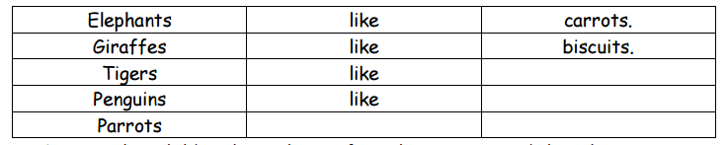

Common exception words for Year 1.

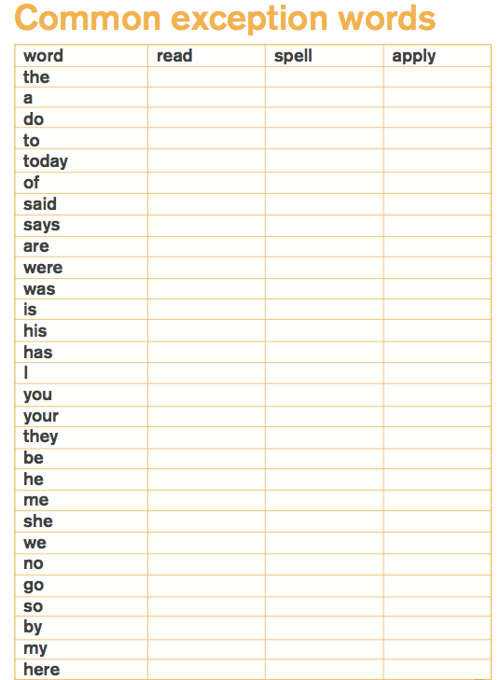

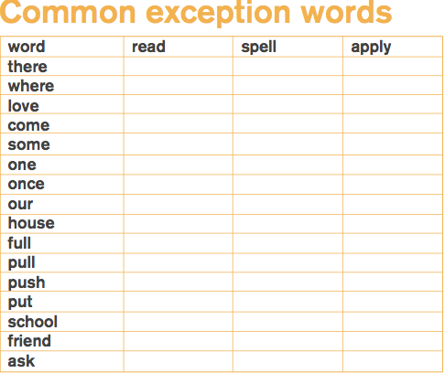

Spelling activities to support your children:

Sound talk  Say words in sounds e.g. ‘Simon says touch your t-oe-s.’ | Wordle  Create your own beautiful word cloud following a spelling pattern: http://www.wordle.net/create | Word shapes  Create your own word shapes challenge: http://tools.atozteacherstuff.com/printable-word-shapes-worksheets/ | Draw your words Use shapes of letters to create drawings e.g. a skyline.
Air and back spelling.  Write the word in the air, really big, then really small, saying each letter as it is written. If the word can be sounded out, use the phonemes, if not, use the letter names. Try writing words on each other's backs and see if your partner can say what word you're writing | Media search  Using a timer, give the children x minutes to find their spelling in the newspaper of magazine. Circle them in bright colours or highlight when they have been found. | Couscous/ salt box spelling  Practice writing spellings in salt or couscous. | Scrabble spelling  Find the letters you need to spell your words, mix them up in a bag and time how quickly you can unscramble them into the words.

Year 1 Grammar

Year 1: Detail of content to be introduced (statutory requirement)
Word | Regular plural noun suffixes –s or –es [for example, dog, dogs; wish, wishes], including the effects of these suffixes on the meaning of the noun  Suffixes that can be added to verbs where no change is needed in the spelling of root words (e.g. helping, helped, helper)  How the prefix un– changes the meaning of verbs and adjectives [negation, for example, unkind, or undoing: untie the boat]
Sentence
  How words can combine to make sentences
  Joining words and joining clauses using and
Text | Sequencing sentences to form short narratives
Punctuation | Separation of words with spaces  Introduction to capital letters, full stops, question marks and exclamation marks to demarcate sentences  Capital letters for names and for the personal pronoun I

Year 1 Grammar Terminology
Letter | A written mark that stands for a speech sound; specific character of an alphabet. | ‘A’ and ‘Z’ are the first and last letters of the alphabet.
Sentence | A complete unit of words in either writing or speech with a clear beginning and a full stop.  A sentence usually has a subject and a verb.  Sentences can state things, ask questions, give commands, or be exclamations. | I got a bike and a football for my birthday.  [I is the subject]  The boy likes to eat chocolate cake.  [the boy is the subject and eat is the verb]
Punctuation | Punctuation marks are essential when you are writing. They show the reader where sentences start and finish and if they are used properly they make your writing easy to understand.  Full stop: a full stop is used at the end of a sentence or abbreviation.  Capital letter: a letter of the alphabet used for proper nouns or start a sentence.  Exclamation mark: an exclamation mark is used after a word or words that express strong feelings.  Question mark: a question mark is mark is used at the end of a sentence that asks a question. | All their meals arrived at the same time.  My dog is called Peaches.  Ow! That hurt!  What time are you going to the fair?
Word | A sound, group of sounds, or the symbols for such sounds in writing that have some meaning. Words are a basic unit of language. | Cat  Mouse  Dog
Singular | The form of a word that names or refers to only one person or thing.
Plural | A plural noun normally has a suffix –s or –es and means “more than one”.  There are a few nouns with different morphology in the plural (e.g. mice) | dogs [more than one dog]  boxes [more than one box]  mice [more than one mouse]

