Parents’ Support Guide to Spelling, Punctuation and Grammar in Year 2.

Writing
By the end of Year 2 most children should know.,,
- What nouns, verbs, adjectives and adverbs are.
- How to expand sentences using subordination – using…when, if, that, because.
- How to expand sentences using coordination – using…or, and, but.
- How to expand noun phrases for description and specification; (e.g. the blue butterfly).
- How to use appropriate adjectives and adverbs to give essential information (e.g. plan flour rather than flour or fluffy, white flour).
- How the grammatical patterns in a sentence indicate its function as a statement, question, exclamation or command.
- How to make the correct choice of present tense and past tense.
- The use of the progressive form of verbs in the present and past tense to mark actions in progress; (e.g. she is drumming; he was shouting).
- The use of capital letters, full stops, question marks and exclamation marks to demarcate sentences. Commas to separate items in a list.
- The use of apostrophes to mark where letters are missing in spelling and to mark singular possession in nouns. (e.g. the girl’s name).

Useful Activities
Perfect Punctuation
Write a short piece of text with full stops in the wrong place. Read it through together. Does it sound right? Alter it by reading through and listening to hear when the sentence is complete. Correct accordingly.

Punctuation Spotter
Print off a piece of text from a book, magazine or the internet. Go through this, highlighting all of the capital letters and full stops. Make a chart to record, “When do we use capital letters?” Do the same with question marks, exclamation marks or verbs and adjectives.

Finish the sentence
Give your child some sentence stems and conjunctions – e.g. The dog ran over the road… when, because, next, etc. Children compose appropriate endings. Discuss. Are the endings interchangeable? Does the meaning change according to the conjunction being used?

Stretchy sentences
To make the sentences longer you need to add more information. e.g. The boy went to the park. The happy, young boy went to play with his friends at the huge, exciting park. or… The tall, brown haired boy was fed up so he went to the park to play with his friends on the fantastic, big climbing frame.

Common exception words for Year 2.

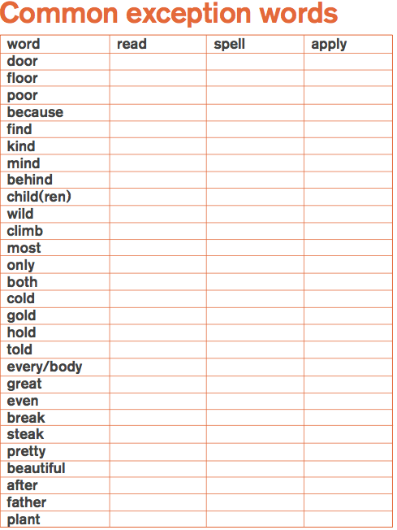

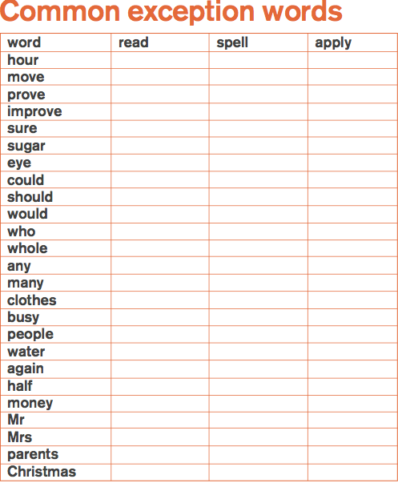

Spelling activities to support your children:

Sound talk  Say words in sounds e.g. ‘Simon says touch your t-oe-s.’ | Wordle  Create your own beautiful word cloud following a spelling pattern: http://www.wordle.net/create | Word shapes  Create your own word shapes challenge: http://tools.atozteacherstuff.com/printable-word-shapes-worksheets/ | Draw your words Use shapes of letters to create drawings e.g. a skyline.
Air and back spelling.  Write the word in the air, really big, then really small, saying each letter as it is written. If the word can be sounded out, use the phonemes, if not, use the letter names. Try writing words on each other's backs and see if your partner can say what word you're writing | Media search  Using a timer, give the children x minutes to find their spelling in the newspaper of magazine. Circle them in bright colours or highlight when they have been found. | Couscous/ salt box spelling  Practice writing spellings in salt or couscous. | Scrabble spelling  Find the letters you need to spell your words, mix them up in a bag and time how quickly you can unscramble them into the words.
Write a story  Write a paragraph / story containing as many words as possible that follow the spelling rule / pattern you are focusing on. | Letter Writing  Write a letter to a friend, family member, teacher or super hero. Underline the spelling rules that you have focused on in your letter. | Colourful words  Use two different colours to write your words- one for vowels another for consonants then write them all in one colour. | Ambidextrous  Swap your pen into the hand that you don't usually write with. Now try writing your spellings with that hand.
Hangman  Write dashes for the letters of the word. Your partner needs to say letters and guess the word before you complete the stick man. | ABC Order  Write a list of your spellings in alphabetical order. For even greater challenge, can you write them in reverse alphabetical order first? | Squiggly / Bubble spelling words  Write a list of your spelling words twice – once in your regular writing, then in squiggly or bubble letters. | Sign your words  Use sign language finger spelling to sign your words. http://www.unitykid.com/signlanguage.html  http://www.british-sign.co.uk/bsl-british- sign-language/fingerspelling-alphabet- charts/

Year 2 Grammar

Year 2: Detail of content to be introduced (statutory requirement)
Word
  Formation of nouns using suffixes such as –ness, –er and by compounding [for example, whiteboard, superman]
  Formation of adjectives using suffixes such as –ful, –less
  (A fuller list of suffixes can be found in the year 2 spelling section in English Appendix 1)
  Use of the suffixes –er, –est in adjectives and the use of –ly in Standard English to turn adjectives into adverbs
Sentence | Subordination (using when, if, that, because) and co-ordination (using or, and, but)  Expanded noun phrases for description and specification [for example, the blue butterfly, plain flour, the man in the moon]  How the grammatical patterns in a sentence indicate its function as a statement, question, exclamation or command
Text | Correct choice and consistent use of present tense and past tense throughout writing  Use of the progressive form of verbs in the present and past tense to mark actions in progress [for example, she is drumming, he was shouting]
Punctuation | Use of capital letters, full stops, question marks and exclamation marks to demarcate sentences  Commas to separate items in a list  Apostrophes to mark where letters are missing in spelling and to mark singular possession in nouns [for example, the girl’s name]

Year 2 Grammar Terminology
Noun | A word that names a person, place, thing, or condition. A noun may be the subject of a sentence or the object of a verb or preposition. | In the sentence, “Joe likes to eat popcorn at the cinema,”  “Joe”, “popcorn” and “cinema” are nouns.
Noun phrase | A noun phrase includes a noun and the modifiers which distinguish it.  If dog is a noun, a noun phrase is a way of giving more information about the dog. | The dog on the sofa.  Uncle Eric’s dog.  The excited dog…
Statement | Something stated in words. | The primary school put out a statement about their new school uniform.
Question | A sentence that asks for a reply. | Did you take my apple?  How long did it take you to get to school?
Exclamation | A single word or phrase that is said when a person has strong feelings. | “Wow!” is an exclamation that people use when they are surprised or amazed.  “Oh dear!” is an exclamation that people use when something disappoints or worries them.
Command | To order or instruct. | She commanded him to leave the building.
Compound | Compound words are made up of two or more different words to make a new one. | Police + man= policeman  Dining + table = dining-table  Hair + cut = haircut
Suffix | A letter or group of letters added to the end of a word to make a new word with a slightly different meaning. | The “ed” in wanted is a suffix.
Adjective | A word that describes or modifies a noun or pronoun. | In the sentence, “It was a hard test,” the word “hard” is an adjective.
Adverb | A word that describes or modifies a verb, adjective, or other adverb. Adverbs are also used to modify a whole sentence. | In the sentence “Unfortunately, she spoke so slowly that most of the audience was very bored,” the words “unfortunately,” “slowly,” and “very” are adverbs.
Verb | An action word. Verbs usually have different forms to express tense, voice, mood, and number. | “Read,” “blew,” “drives” “seemed,” and “skip” are examples of verbs.
Tense  (past, present) | The aspect of verbs that shows when an action takes place.  Verbs can be in past, present, or future tense. | Played (past tense)  Playing (present tense)  To play (future tense).
Apostrophe | An apostrophe is used to show where one or more letters or numbers have been left out.  It is also used to show possession. | “Wouldn’t” for “would not”  “’87” for “1987”  Susan’s clothes.
Comma | A comma is used to separate words, phrases, or other parts of a sentence or list, or to show a pause in speech. | “I went to the market and bought eggs, chicken, milk and cheese.”

